**准均匀B样条曲线**

**Order ：B样条曲线次数**

**Knots：B样条曲线参数节点数组**

**控制点：6个：**

**{**

**new Point3d(-0.6,0.1,0.1),**

**new Point3d(-0.4,0.25,0.1),**

**new Point3d(-0.1,0.25,0.1),**

**new Point3d(0.3,-0.25,0.1),**

**new Point3d(0.5,-0.2,0.1),**

**new Point3d(0.65,0.3,0.1)**

**}**

**order=1;knots={0.0,0.0,0.2,0.4,0.6,0.8,1.0,1.0};**

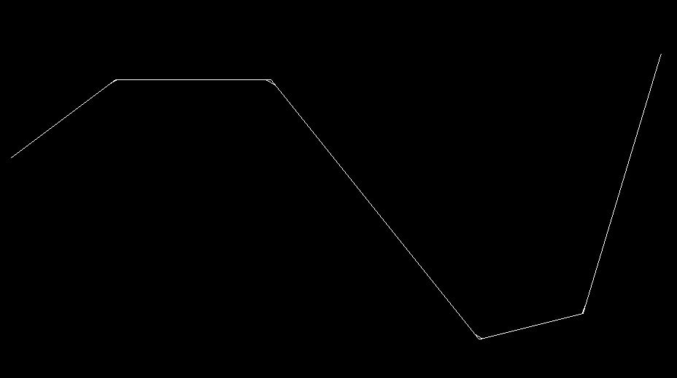

**order=2; knots={0.0,0.0,0.0,0.25,0.5,0.75,1.0,1.0,1.0};**

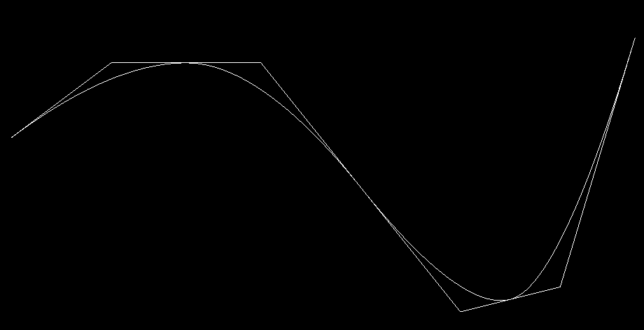

**order=3; knots={0.0,0.0,0.0,0.0,0.33,0.66,1.0,1.0,1.0,1.0};**

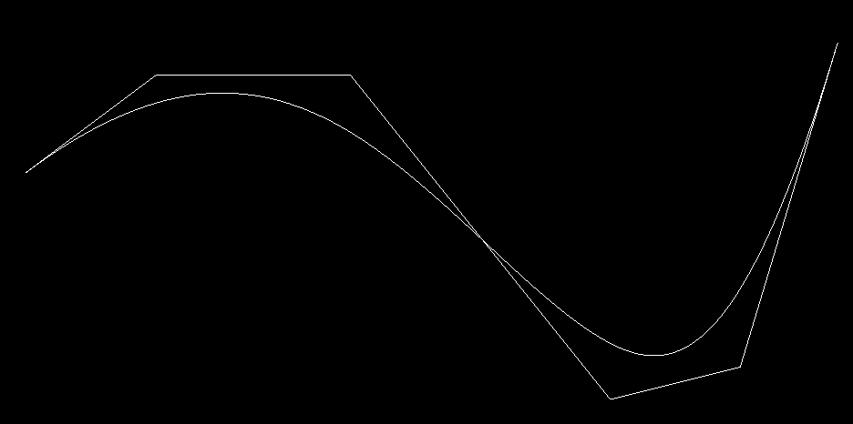

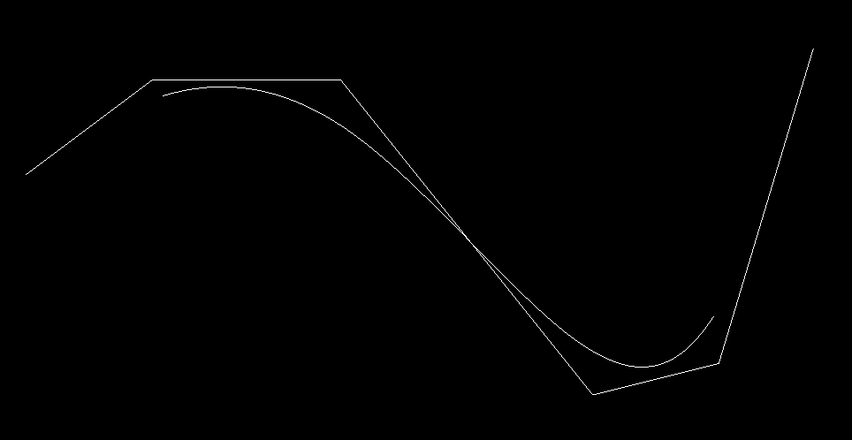

**order=4; knots={0.0,0.0,0.0,0.0,0.0,0.5,1.0,1.0,1.0,1.0,1.0};**

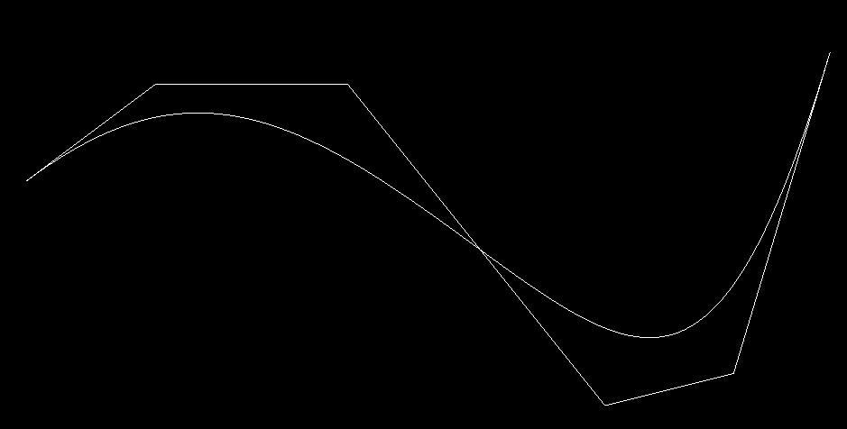

**order=5;**

**knots={0.0,0.0,0.0,0.0,0.0,0.0,1.0,1.0,1.0,1.0,1.0,1.0};**

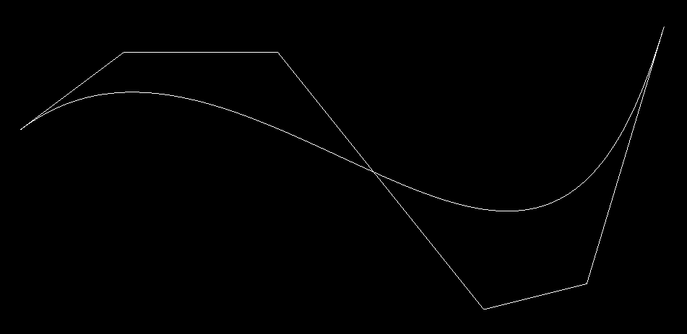

**节点个数=控制点个数+B样条曲线次数+1**

**u=0.0或u=1.0端点处各有（B样条曲线次数+1）个重复节点**

**1端点有B样条曲线次数+1个重复节点**

**B样条曲线与分段Beziér曲线**

**ctrlPoints=new Point3d[]**

**{**

**new Point3d(-0.2,-0.1,0.1),**

**new Point3d(-0.3,0.15,0.1),**

**new Point3d(-0.1,0.25,0.1),**

**new Point3d(0.3,0.28,0.1),**

**new Point3d(0.4,-0.1,0.1),**

**new Point3d(0.1,-0.3,0.1)**

**};int order=3;double[] knots={0,0,0,0,0.5,0.5,1,1,1,1};**

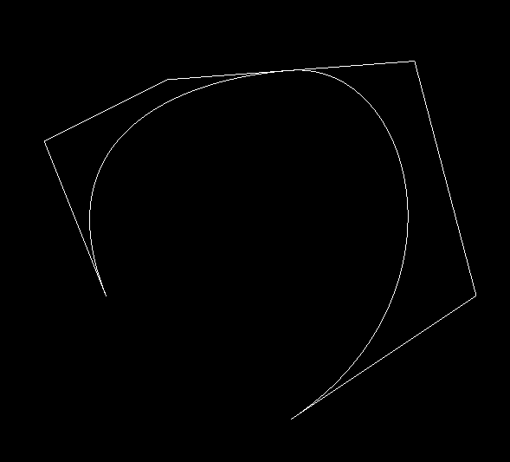

**ctrlPoints=new Point3d[]**

**{**

**new Point3d(-0.1,-0.25,0.1),**

**new Point3d(-0.25,-0.15,0.1),**

**new Point3d(-0.2,0.15,0.1),**

**new Point3d(0.0,0.25,0.1),**

**new Point3d(0.4,0.11,0.1),**

**new Point3d(0.3,-0.15,0.1),**

**new Point3d(0.1,-0.18,0.1)**

**};**

**int order=3;double[] knots={0,0,0,0,0.5,0.5,0.5,1,1,1,1};**

